Setting up a FREE Zoom account and downloading the app.

To join together online in bible study and worship we are using ZOOM video-conference software.

You can use your computer, phone, tablet, laptop, whatever you have available. We also recommend using headphones/Ear Plugs plugged into your device to get the best experience and cut out background noise.

Here are the instructions for downloading the App and signing up with a Free Zoom account so that you can join in a video-conference meeting.

After you have followed these instructions and are ready to use Zoom, you will receive an email or text with a link to join the test meeting tonight at 5pm. Log in to the Zoom App and then click the link in the email to join the test meeting.

GOING TO THE ZOOM WEBSITE
- On a computer/laptop - In your web browser go to https://zoom.us/
and click the “sign up it’s free” button.
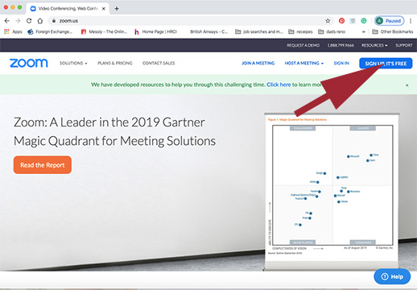

SIGNING UP FOR FREE
You need to sign-up for a Free Zoom account to use the software
- Enter your email address and then click the blue “Sign Up” button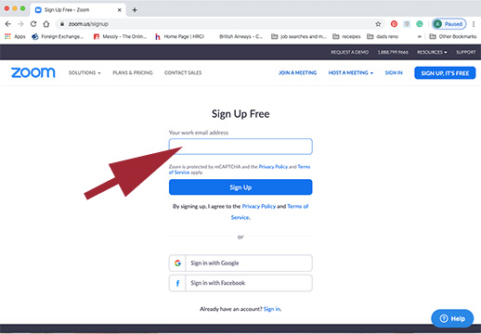

CHECK YOUR EMAIL TO ACTIVATE ZOOM!
- You can now go to your email and you should see an email from ZOOM in your Inbox. Click the blue “Activate Account” button.
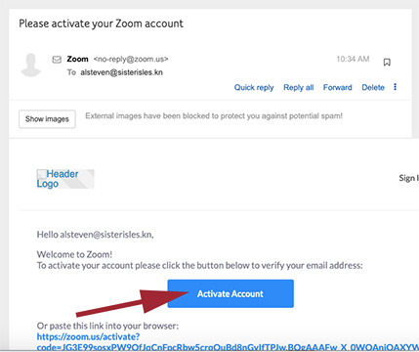

CREATE A PASSWORD FOR YOUR FREE ACCOUNT

- A new web page should pop up where you can now create a password.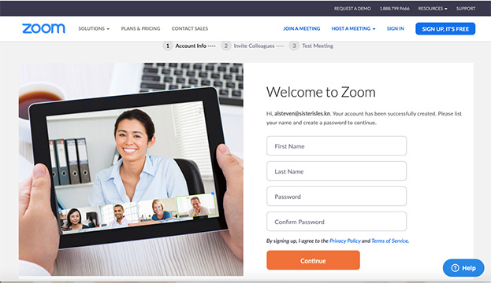
- Enter your First name, Last Name, and then enter a password. Please make sure that your password meets these requirements:
- Must be at least 8 characters
- Cannot be longer than 32 characters
- Have at least 1 letter (a, b, c...)
- Have at least 1 number (1, 2, 3...)
- Include both uppercase and lower case letters
- Cannot contain only one character (i.e., "111111" or "aaaaaa")
- Cannot contain consecutive characters (i.e., "123456" or "abcdef")

- Enter your password again and then click on the orange “Continue” button.

- On the next screen, check the “I am not a robot” option and then click on the “Skip This Step” button
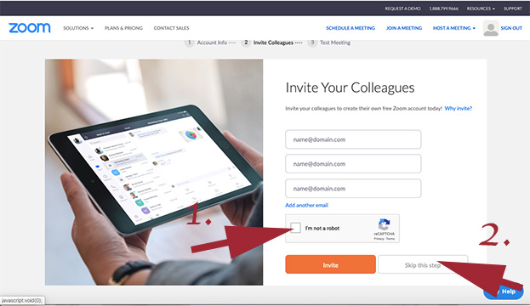

DOWNLOADING ZOOM
The software should now automatically download to your computer. You may see a box open up on your computer like this:
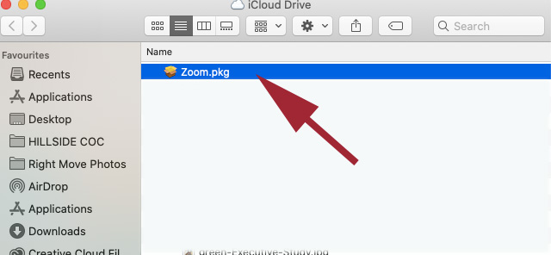

- Click the continue button so that. The software can run through:
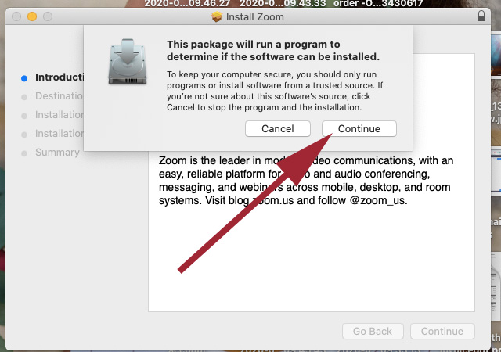
ALLOWING ZOOM TO ACCESS YOUR COMPUTER’S VIDEO AND AUDIO
- In order for Zoom to work properly, you should allow the Zoom software to access your computer’s audio and video hardware. You will see a series of options similar to these screenshots asking for access. 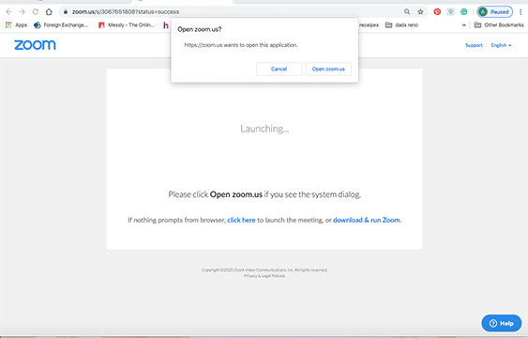

- Let Zoom send you notifications by clicking on the “Allow” button: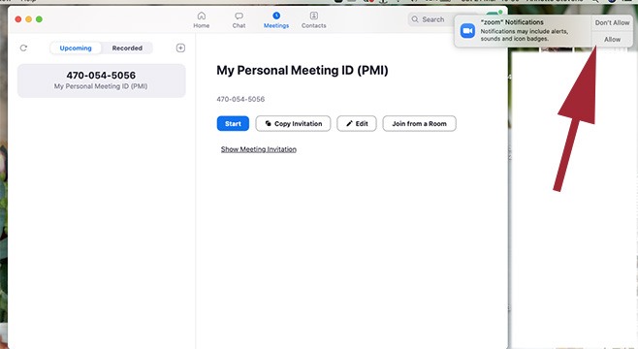

- You can select the options to “Join with Computer Audio” and “Automatically join audio by computer when joining a meeting”
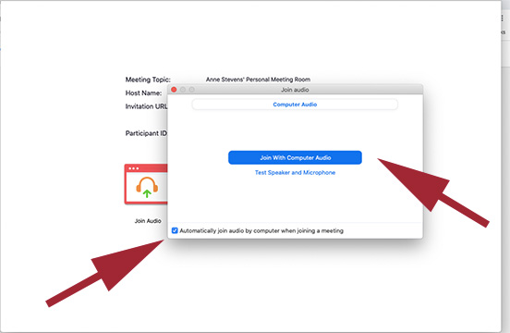
- Click the button at the bottom of the screen to turn your video on so that everyone can see you and you can see everyone once on a video call: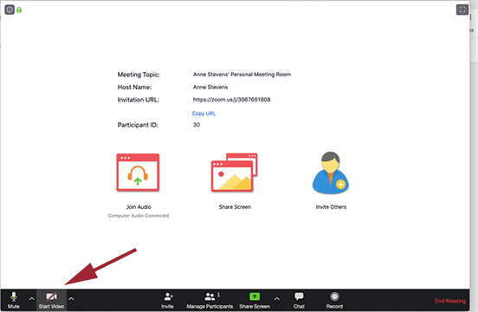

You are now ready to start a ZOOM video meeting!!

